**PIZZA SALES SQL QUERIES**

1. **Total Revenue:**

SELECT SUM(total_price) AS Total_Revenue FROM pizza_sales;

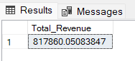

1. **Average Order Value**

SELECT (SUM(total_price) / COUNT(DISTINCT order_id)) AS Avg_order_Value FROM pizza_sales

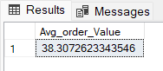

1. **Total Pizzas Sold**

SELECT SUM(quantity) AS Total_pizza_sold FROM pizza_sales

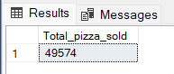

1. **Total Orders**

SELECT COUNT(DISTINCT order_id) AS Total_Orders FROM pizza_sales

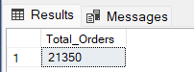

1. **Average Pizzas Per Order**

SELECT CAST(CAST(SUM(quantity) AS DECIMAL(10,2)) /

CAST(COUNT(DISTINCT order_id) AS DECIMAL(10,2)) AS DECIMAL(10,2))

AS Avg_Pizzas_per_order

FROM pizza_sales

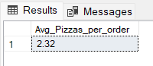

1. **Hourly Trend for Total Pizzas Sold**

SELECT DATEPART(HOUR, order_time) as order_hours, SUM(quantity) as total_pizzas_sold

from pizza_sales

group by DATEPART(HOUR, order_time)

order by DATEPART(HOUR, order_time)

***Output***

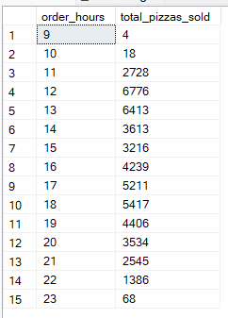

**7. Weekly Trend for Orders**

SELECT

DATEPART(ISO_WEEK, order_date) AS WeekNumber,

YEAR(order_date) AS Year,

COUNT(DISTINCT order_id) AS Total_orders

FROM

pizza_sales

GROUP BY

DATEPART(ISO_WEEK, order_date),

YEAR(order_date)

ORDER BY

Year, WeekNumber;

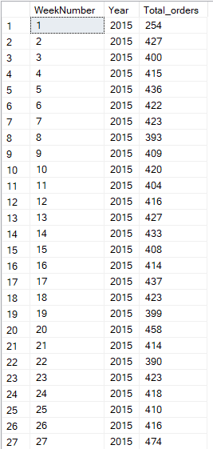 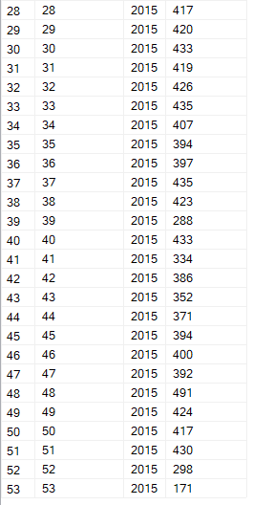

**8.% of Sales by Pizza Category**

SELECT pizza_category, CAST(SUM(total_price) AS DECIMAL(10,2)) as total_revenue,

CAST(SUM(total_price) * 100 / (SELECT SUM(total_price) from pizza_sales) AS DECIMAL(10,2)) AS PCT

FROM pizza_sales

GROUP BY pizza_category

***Output***

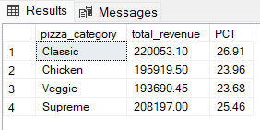

**9. % of Sales by Pizza Size**

SELECT pizza_size, CAST(SUM(total_price) AS DECIMAL(10,2)) as total_revenue,

CAST(SUM(total_price) * 100 / (SELECT SUM(total_price) from pizza_sales) AS DECIMAL(10,2)) AS PCT

FROM pizza_sales

GROUP BY pizza_size

ORDER BY pizza_size

***Output***

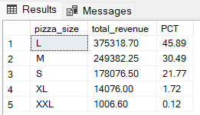

**10. Total Pizzas Sold by Pizza Category**

SELECT pizza_category, SUM(quantity) as Total_Quantity_Sold

FROM pizza_sales

WHERE MONTH(order_date) = 2

GROUP BY pizza_category

ORDER BY Total_Quantity_Sold DESC

***Output***

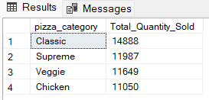

**11. Top 5 Pizzas by Revenue**

SELECT Top 5 pizza_name, SUM(total_price) AS Total_Revenue

FROM pizza_sales

GROUP BY pizza_name

ORDER BY Total_Revenue DESC

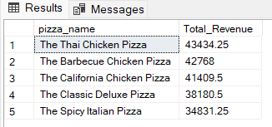

**12. Bottom 5 Pizzas by Revenue**

SELECT Top 5 pizza_name, SUM(total_price) AS Total_Revenue

FROM pizza_sales

GROUP BY pizza_name

ORDER BY Total_Revenue ASC

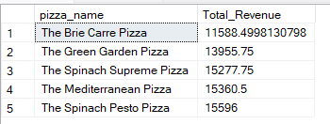

**13. Top 5 Pizzas by Quantity**

SELECT Top 5 pizza_name, SUM(quantity) AS Total_Pizza_Sold

FROM pizza_sales

GROUP BY pizza_name

ORDER BY Total_Pizza_Sold DESC

***Output***

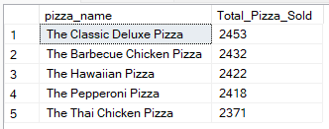

**14. Bottom 5 Pizzas by Quantity**

SELECT TOP 5 pizza_name, SUM(quantity) AS Total_Pizza_Sold

FROM pizza_sales

GROUP BY pizza_name

ORDER BY Total_Pizza_Sold ASC

***Output***

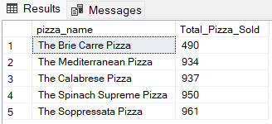

**15. Top 5 Pizzas by Total Orders**

SELECT Top 5 pizza_name, COUNT(DISTINCT order_id) AS Total_Orders

FROM pizza_sales

GROUP BY pizza_name

ORDER BY Total_Orders DESC

